COVER PAGE

PROJECT TITLE: STUDENT ADMISSION FORM DATA COLLECTOR

COURSE -CSE1021

INSTRUCTOR-DR.M.MANI MARAN

SUBMITTED BY-SHIVAM KUMAR SHAH

REG.NUM.-25BAI10991

DATE-24 NOVEMBER 2025 INSTITUTION-VIT BHOPAL

INTRODUCTION
The Student Admission Form Data Collector project aims to simplify and automate the process of gathering, storing, and managing student admission data.
the Student Admission Form Data Collector is a digital system that replaces the old-fashioned, paper-based admissions process for a school, college, or university. Instead of having stacks of paperwork to fill out, manage, and store, this tool provides a simple, online way to handle everything. It’s main objective is to create a reliable and user-friendly data collection tool that can be used by educational institutions for managing student admissions.

Problem Statement

Educational institutions often face challenges when handling large volumes of student admission data. Common issues include:

Manual Data Entry: Admission forms are traditionally filled out by hand or through paper forms, which can lead to mistakes and delays in processing.

Data Management: Once data is collected, it may not be stored in a structured, making it difficult to analyze.

Security Concerns: Physical forms are prone to damage, loss, or unauthorized access.

Efficiency: Collecting and processing student data manually is very time consuming and inefficient, particularly during peak admission periods.

This project seeks to solve these issues by creating an automated Student Admission Form Data Collector system that:

Collects and validates data efficiently.

Stores data in a secure and organized manner.

Provides easy access to admission records for administrative staff.

Functional Requirements
The Student Admission Form Data Collector system should be able to perform the following functions:
Form Creation
The system needs to let us build a simple, attractive online application form that students can easily open on their computer or phone to type in all their information.
Data Collection
The system should collect key student information including:
a).Personal Details
b).Academic Details
c). Course Preferences
d).Additional Information
Data Validation
The system should validate the input data to ensure that all fields are filled correctly and Alerts or error messages should be displayed if any required fields are missing or incorrect.
Data Storage
The system should store the data in a database (e.g., SQLite, MySQL, or CSV) to ensure that it is easily retrievable for future use.
Data Retrieval
Admin users should be able to retrieve and view the student records.
User Authentication
Admin users should have a secure login system to access the data collection interface and the student records.
Exporting Data
The system should allow exporting the student data to common file formats like CSV or Excel for reporting purposes.
User Interface
The system should feature a clean, simple, and user-friendly interface that is easy for students and administrative staff to navigate.
Error Handling
The system should gracefully handle errors such as failed data submissions or invalid data formats, with proper feedback to users.
Non-functional Requirements
The non-functional requirements are the system's attributes that ensure its performance, usability, and reliability.
- Performance:
  - The system should be able to handle a large number of submissions without lag or downtime.
  - Data submission should occur in real time, with minimal delay.
- Usability:
  - The system should be easy to use for both students and administrative users. The user interface should be intuitive, with clear instructions.
  - Forms should be responsive and function well on different devices (desktops, tablets, and smartphones).
- Scalability:
  - The system should be scalable to handle a growing number of student submissions over time, including the possibility of adding new features as needed.
- Security:
  - Data should be securely stored and protected, using encryption or other security measures to prevent unauthorized access.
  - Passwords and other sensitive information should be securely hashed and never stored in plain text.
  - Regular backups should be made to prevent data loss.
- Reliability:
  - The system should be reliable and available 24/7, with minimal downtime or technical issues.
  - It should have error logs and alerts for system malfunctions or failures.
- Compliance:
  - The system must comply with relevant data privacy laws and regulations, such as GDPR (General Data Protection Regulation) for institutions in the EU or FERPA (Family Educational Rights and Privacy Act) in the US.
- Maintainability:
  - The code should be well-documented, modular, and easy to maintain.
  - Future developers should be able to understand and modify the system easily.
- Portability:
  - The system should be able to run on various platforms (Windows, macOS, Linux) without issues.

System Architecture
The system architecture describes the overall structure of the system and how different components interact with each other. In a Student Admission Form Data Collector project, this may involve:
- Frontend (User Interface):
  - A web or command-line interface where users (students) input their details such as personal information, academic qualifications, etc.
- Backend (Data Processing):
  - Python scripts or a web server (Flask/Django) that collect, validate, and process data.
- Database (if used):
  - A database like SQLite, MySQL, or MongoDB to store student details.
  - The database schema will include tables/collections for students, courses, admissions, etc.
- Validation Layer:
  - A layer where input data is validated for correctness (e.g., ensuring that email addresses are valid, age falls within a reasonable range, etc.).
- Reporting/Export:
  - A system for generating reports (e.g., CSV or PDF export) of collected student data for administrative use.
Design Diagrams
Use Case Diagram
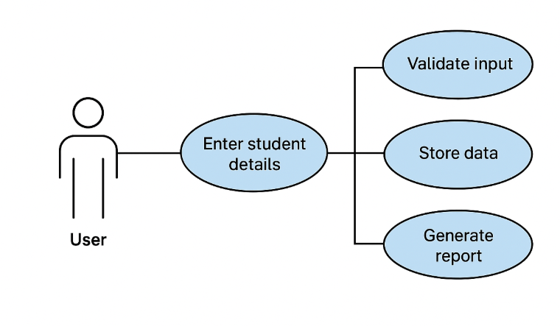

Workflow Diagram
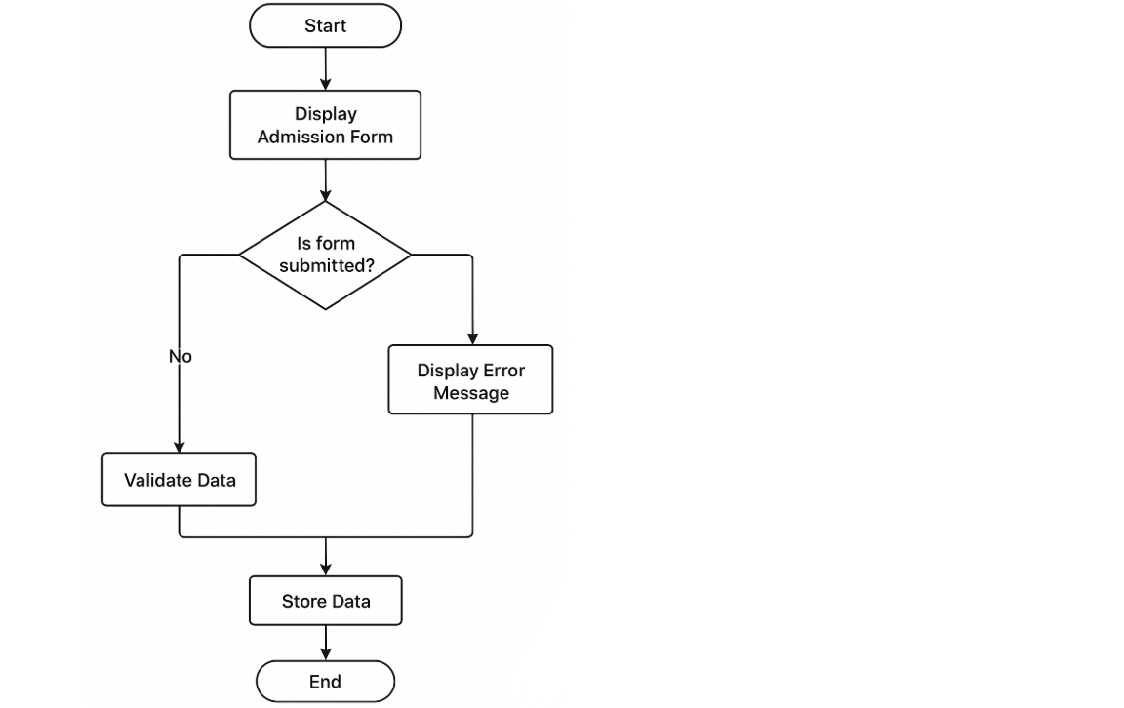

Sequence Diagram

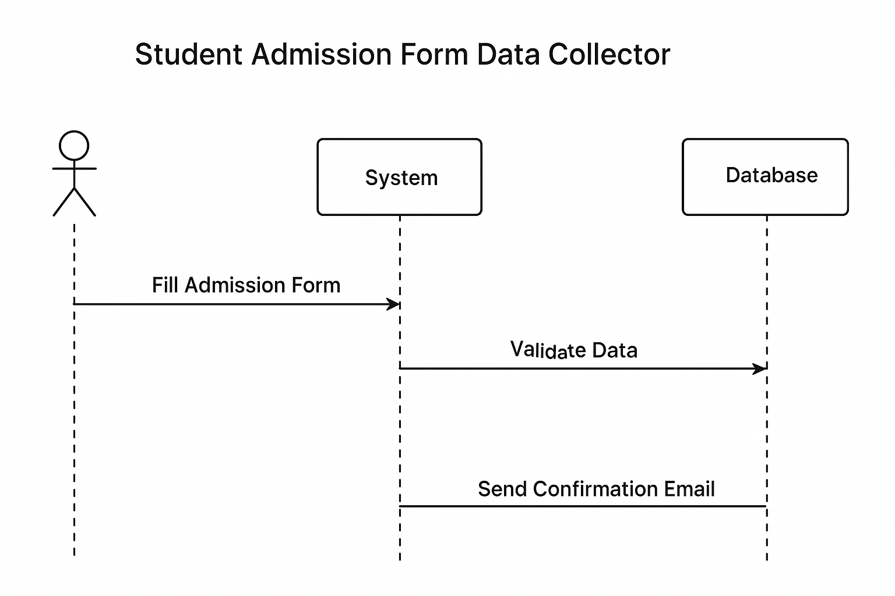

Class/Component Diagram
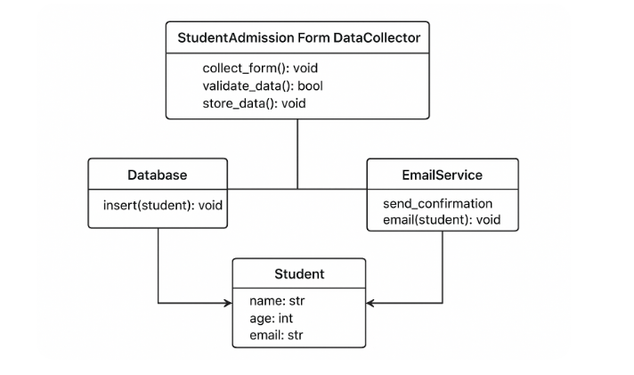
Design Decisions & Rationale
High-level goals
- Keep the system simple and maintainable.
- Separate concerns: UI / input collection, validation, persistence, and notifications.
- Use lightweight, standard libraries (Flask for web UI or simple CLI, SQLite for storage) to minimize deployment friction.
- Make testing straightforward (unit-testable validation and DB wrappers).
Architecture
- Component-based: FormCollector (controller), Student model, Database (persistence adapter), EmailService (notification).
  - Rationale: clear boundaries make unit testing easier and allow swapping implementations (e.g., SQLite → Postgres, SMTP → external email API).
- Synchronous flow with clear error handling:
  - Collect → Validate → Store → Notify.
  - Rationale: Simple admission forms are typically short-lived transactions where immediate validation and storage are desirable.
- Single source of truth for validation rules:
  - validation logic is in one module/class so both UI and API paths can reuse it.
Technology choices
- Python 3.10+ — modern typing features and dataclasses.
- Flask (or CLI) for the simplest web UI.
- SQLite for prototyping (file DB); use SQLAlchemy or plain sqlite3 wrapper.
- smtplib for emails in dev; production apps should use an email API (SendGrid, Mailgun).
- pytest for tests.
Implementation Details
The system is built in Python using a modular design that separates data collection, validation, storage, and notification.

A Student data model (using Python’s dataclass) stores student details such as name, age, email, phone, and selected program.

User data is collected through either:

a Flask web interface for online form submissions, or

a command-line interface (CLI) for simple offline use.

After submission, data is passed to a validation module that checks required fields, verifies value formats (e.g., email), and ensures logical constraints like valid age ranges.

Valid student data is forwarded to a database module using SQLite; the Database class automatically creates the table and handles record insertion.

If the insertion is successful, a confirmation email is sent to the applicant using Python’s smtplib library.

The email module constructs a personalized message and sends it through a configured SMTP server.

Each major feature—data collection, validation, database operations, and email sending—is implemented in a separate Python module for easier maintenance and scalability.

The complete workflow follows a consistent sequence: Collect Data → Validate Data → Store in Database → Send Confirmation Email.

The design focuses on code readability, reusability, and a clean flow that can be easily extended in future versions of the project.
Results
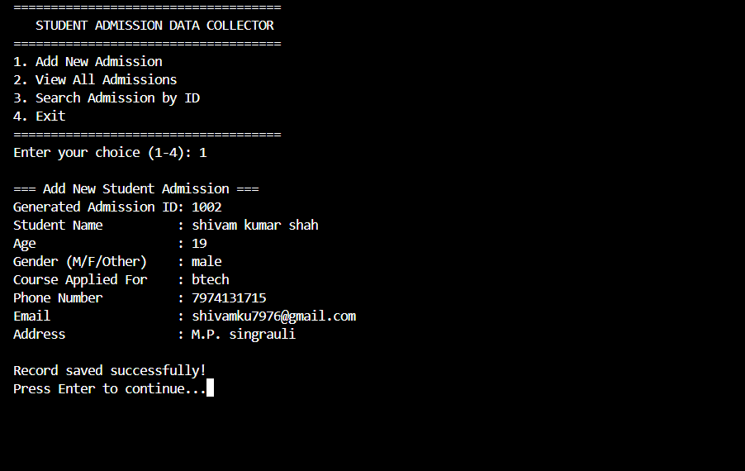

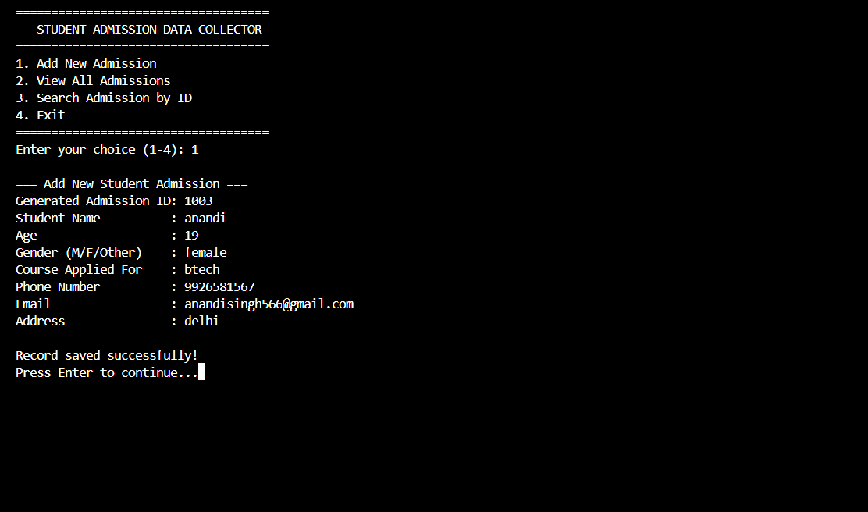
Testing Approach
Unit Testing
- Tested the validation module with different input scenarios (missing fields, invalid email, incorrect age values).
- Ensured that valid inputs pass successfully and invalid inputs produce accurate error messages.
- Used an in-memory SQLite database to test database insert operations without affecting real data.
- Verified handling of constraints, such as preventing duplicate email entries.
• Integration Testing
- Tested the complete workflow by submitting sample data through the Flask API or CLI.
- Ensured smooth data flow across modules: collection → validation → storage → email notification.
- Mocked email sending functionality to simulate message delivery without needing a live SMTP server.
• Manual Testing
- Submitted forms through the real user interface to observe system behavior.
- Checked database entries to confirm that records were inserted correctly.
- Verified that confirmation messages/emails were triggered after successful submissions.
• Overall Outcome
- Ensured the system is robust, stable, and capable of handling both valid and invalid data inputs effectively.
Challenges Faced
• Handling Input Validation Edge Cases
Designing validation rules that were both strict and user-friendly was challenging, especially for fields like phone numbers, age limits, and email formats. Ensuring that every possible invalid input was caught required multiple iterations.
• Database Constraints and Data Integrity
SQLite is simple to use, but enforcing constraints—such as preventing duplicate email submissions—led to issues when handling errors gracefully without crashing the application.
• Email Configuration and Delivery Issues
Setting up an SMTP server for sending confirmation emails was difficult during initial testing. Incorrect configurations, blocked ports, and authentication failures slowed development.
• Maintaining Modular Structure
Ensuring separation between validation, storage, and communication modules required careful planning to avoid circular dependencies and to keep the codebase maintainable.
• Managing Concurrency with SQLite
Since SQLite allows only one write operation at a time, there were occasional locking issues during rapid or simultaneous submissions.
• Testing the Entire Workflow
Simulating the complete pipeline—collecting data, validating it, inserting it into the database, and sending an email—required integration tests and mocking tools, which added complexity.
• User Interface Feedback
Providing clear and helpful error messages for invalid inputs was difficult, especially when trying to ensure consistency across CLI and web-based forms.

Learnings & Key Takeaways
• Importance of Modular Design
Building separate modules for validation, database operations, and email services highlighted how modularity improves readability, debugging, and future scalability.
• Value of Input Validation
Creating a strong validation layer demonstrated how essential it is to handle incorrect or malicious inputs and ensure data accuracy before storing it.
• Practical Experience with Databases
Working with SQLite helped reinforce concepts like schema design, primary keys, constraints, and handling database errors such as duplicate entries or write locks.
• Understanding Backend Workflow
Implementing a full pipeline—collecting data, validating it, saving it, and sending notifications—provided hands-on experience with how real backend systems process user data.
• Importance of Error Handling
Encountering issues with data formats, email configuration, and database operations highlighted the need for graceful error handling and meaningful user feedback.
• Testing as a Crucial Step
Unit tests, integration tests, and manual tests showed the importance of thorough testing in building a reliable and stable application.
• Working with External Services
Integrating SMTP email delivery offered insights into configuring external services, handling authentication, and managing potential delivery failures.
• Scalability Considerations
Experiencing limitations of SQLite and synchronous processing helped identify how future improvements (like switching to PostgreSQL or using asynchronous tasks) could enhance system performance.
Future Enhancements
• Graphical User Interface (GUI)
Implement a user-friendly interface using Tkinter, PyQt, or Kivy to make data entry easier and more intuitive.
• Database Integration
Replace flat-file storage (CSV/JSON/Text) with a proper database such as SQLite, MySQL, or PostgreSQL for secure, scalable, and faster data handling.
• Automated Data Validation
Add advanced validation such as checking email formats, phone number patterns, duplicate entries, and required fields to prevent incorrect submissions.
• Web-Based Submission Portal
Convert the project into a web application using Flask or Django so students can submit their forms online.
References
• Python Software Foundation. Python Documentation. Available at: https://docs.python.org/
• Tkinter GUI Documentation. Available at: https://docs.python.org/3/library/tkinter.html
• SQLite Documentation. Available at: https://www.sqlite.org/docs.html
• W3Schools. Python Tutorial. Available at: https://www.w3schools.com/python/

